Student’s Full Name: Surajit Pal

Course Title: Data Warehousing and Analytics in the Cloud

Term name and year: Spring 2023

Submission Week: Week 3- Assignment 2

Instructor’s Name: Dr. Nayem Rahman

Date of Submission: 15 – Nov – 2023

**Q1. Show the screenshot of a successful installation of MySQL Software and MySQL**

**Workbench with the latest version on your machine. Show the screenshot of the database**

**“Worker” created**





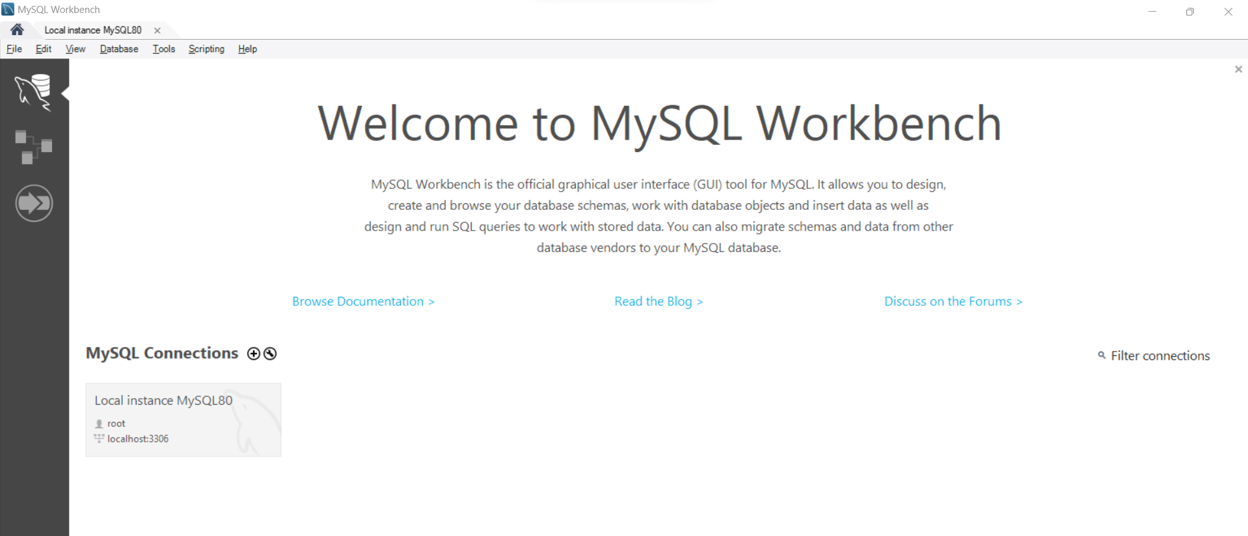

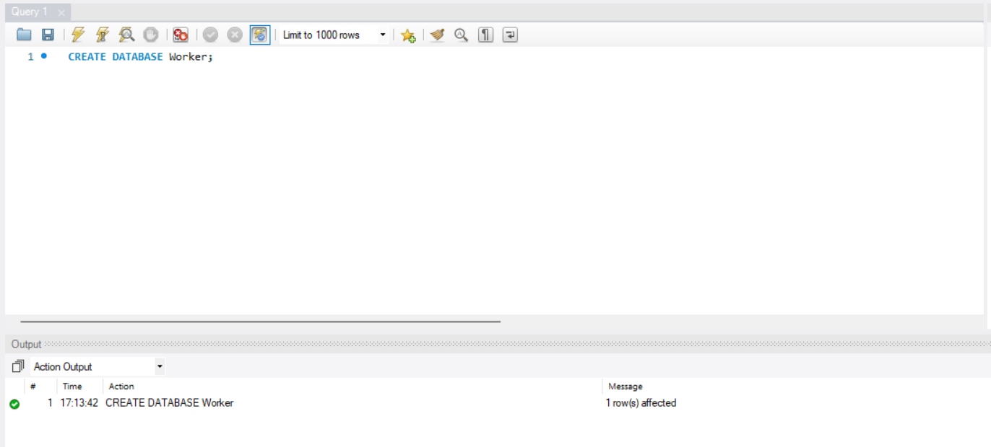

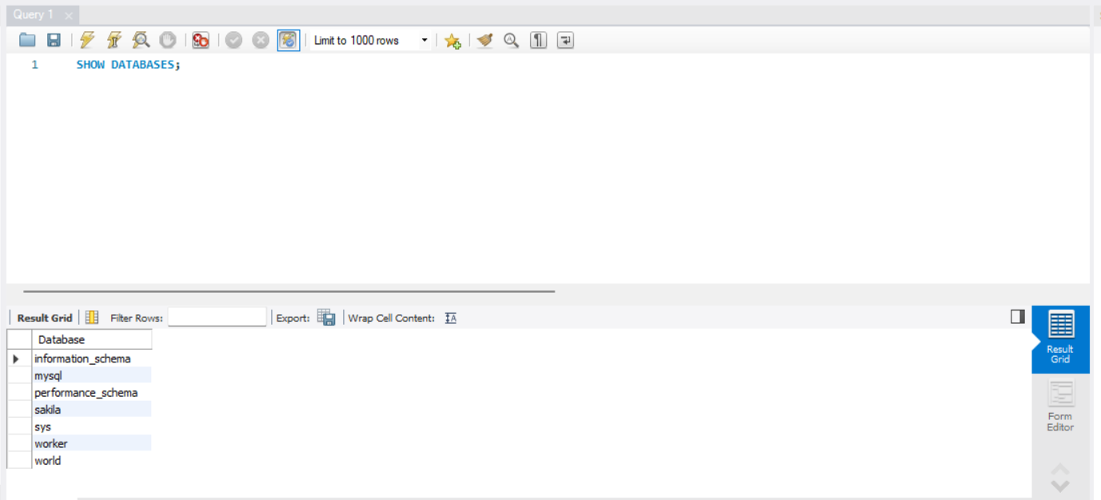

**Q2. Create the Department table in the Worker database (table must be based on Physical**

**Model Provided in the Assignment folder). (a) Columns, Primary Key (PK), Data Type &**

**length, and NULL/NOT NULL need to be implemented, as provided in the Physical Model.**

**(b) Show the table definition (DDL) that you implemented. (c) Insert the complete set of data**

**provided in the Excel file (uploaded in the Assignment folder) and show the insert**

**statements used. (d) Retrieve the data from the Department table by using the SELECT \***

**statement and order by PK column(s). Show the output. Make sure you show the print**

**screen of the complete set of the rows and columns. The rows must be ordered by PK**

**column(s).**

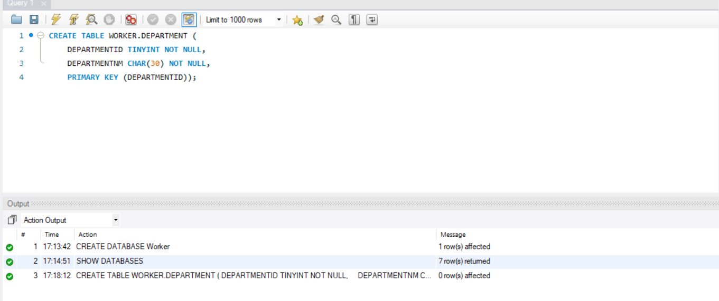

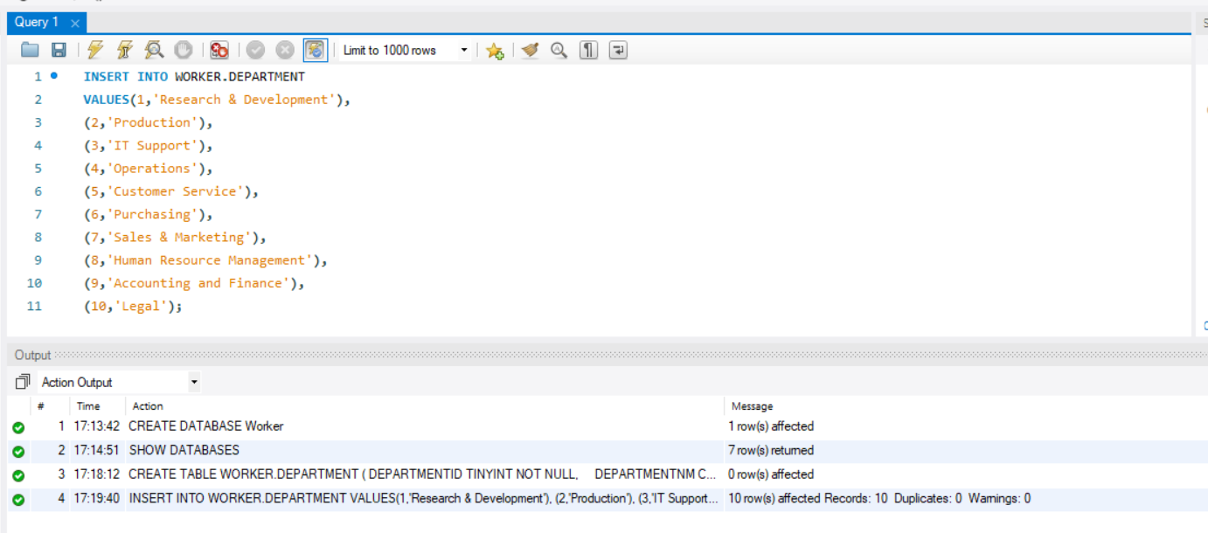

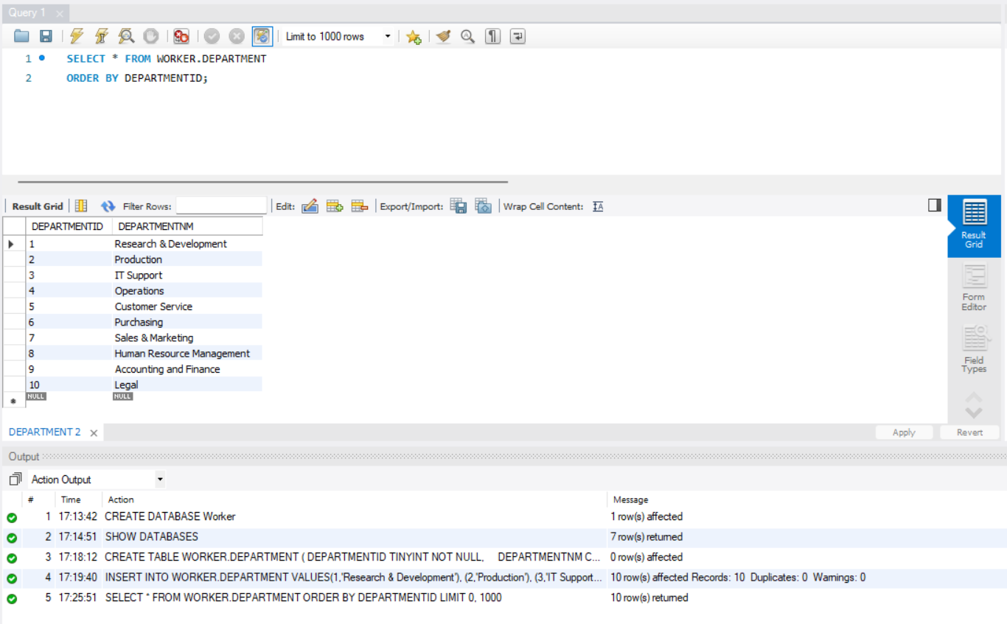

**Q3. Create the Employee table in the Worker database (table must be based on Physical**

**Model Provided in the Assignment folder). (a) Columns, Primary Key (PK), Data Type and**

**length, and NULL/NOT NULL need to be implemented, as provided in the Physical Model.**

**(b) Show the table definition (DDL) that you implemented (not in a graphical view). (c) Insert**

**the complete set of data provided in the Excel file (uploaded in the Assignment folder) and**

**show the insert statements used. (d) Retrieve the data from the Employee table by using the**

**SELECT * statement and order by PK column(s). Show the output. Make sure you show the**

**print screen of the complete set of the rows and columns. The rows must be ordered by PK**

**column(s).**

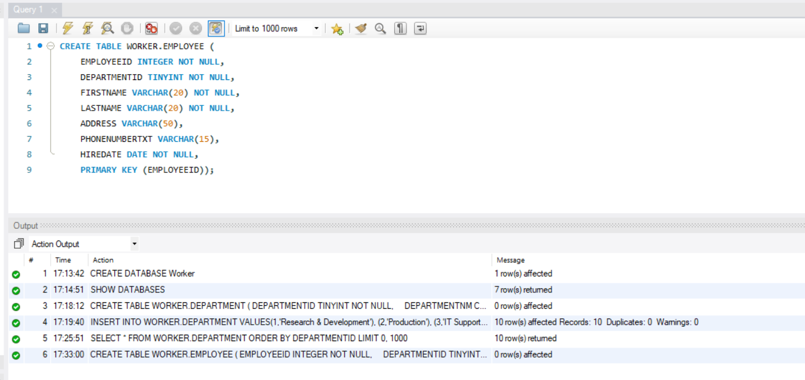

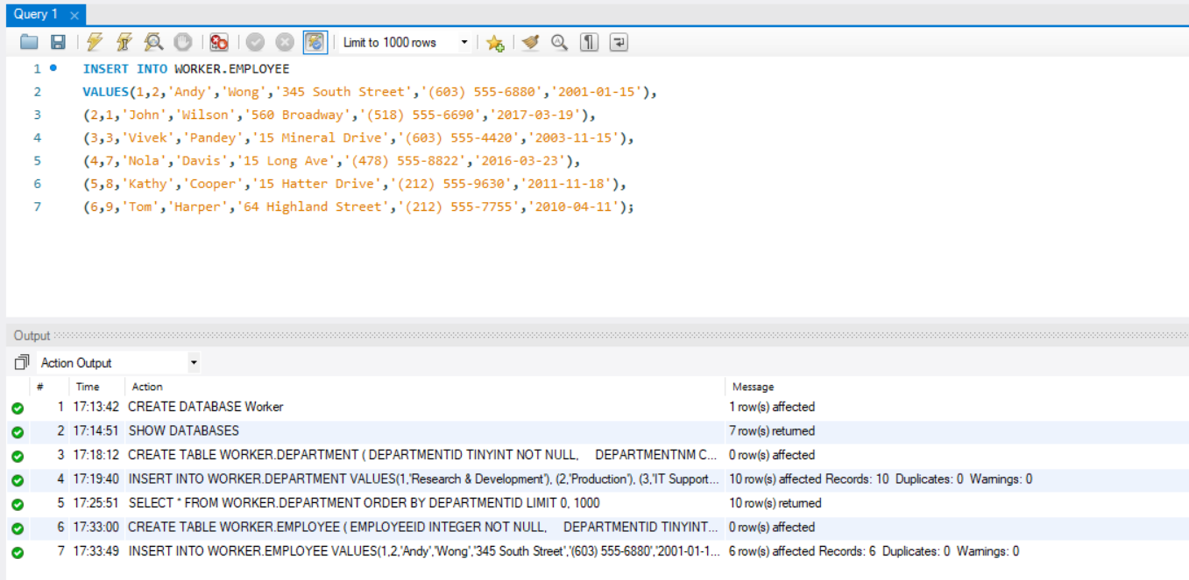

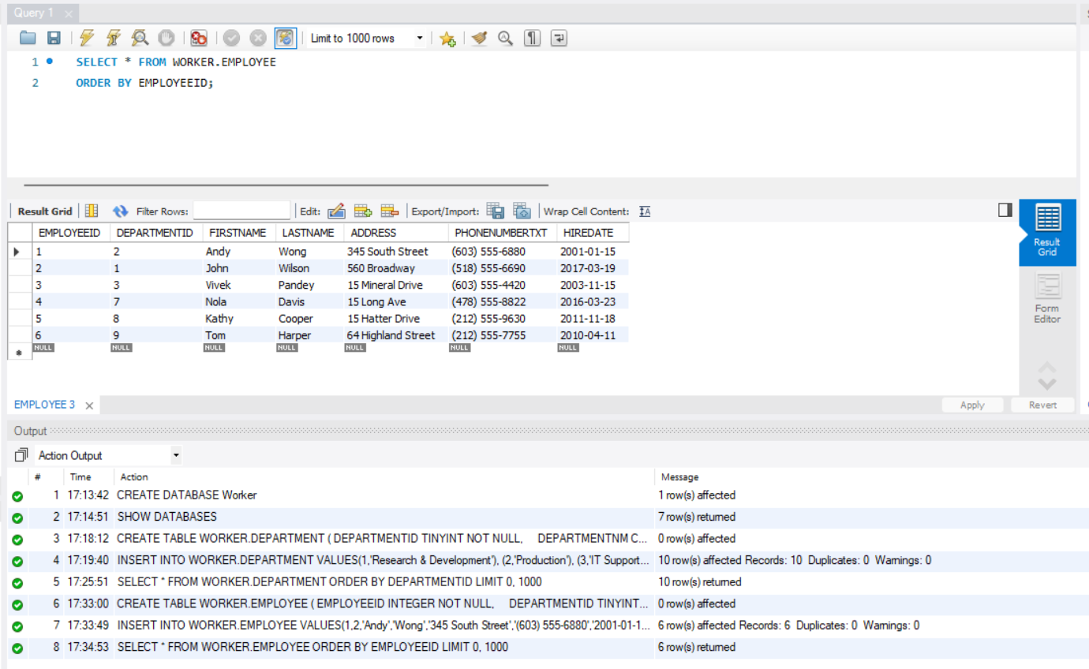

**Q4. Create the Equipment table in the Worker database (table must be based on Physical**

**Model Provided in the Assignment folder). (a) Columns, Primary Key (PK), Data Type &**

**length, and NULL/NOT NULL need to be implemented, as provided in the Physical Model.**

**(b) Show the table definition (DDL) that you implemented. (c) Insert the complete set of data**

**provided in the Excel file (uploaded in the Assignment folder) and show the insert**

**statements used. (d) Retrieve the data from the Equipment table by using the SELECT \***

**statement and order by PK column(s). Show the output. Make sure you show the print**

**screen of the complete set of the rows and columns. The rows must be ordered by PK**

**column(s).**

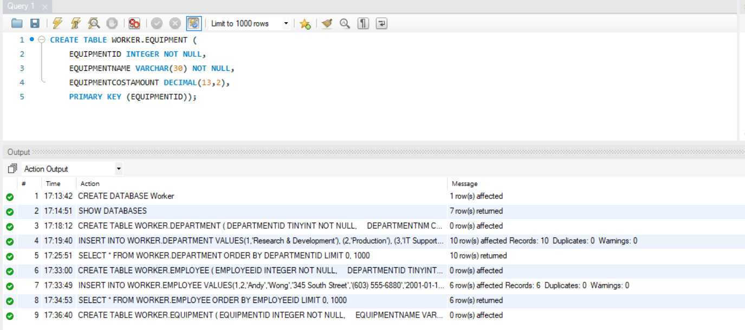

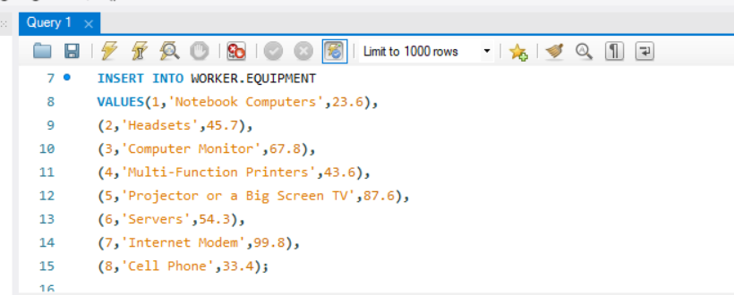

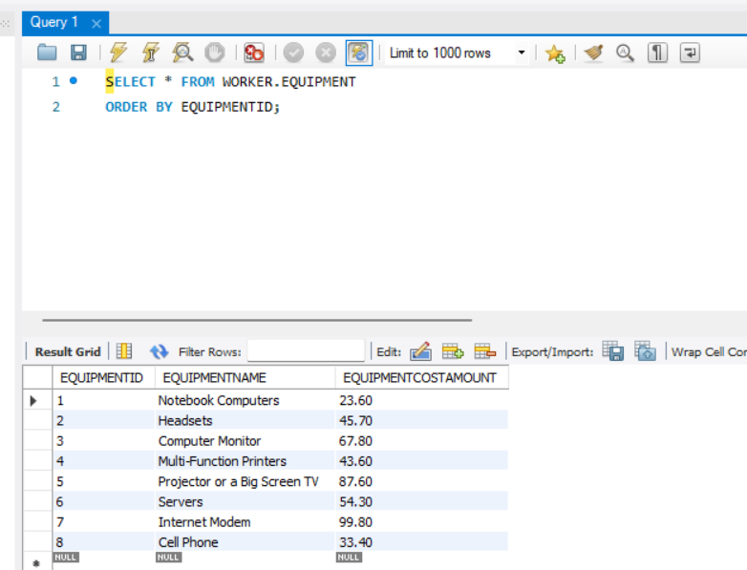

**Q5. Create the EmployeeEquipment table in the Worker database (table must be based on**

**Physical Model Provided in the Assignment folder). (a) Columns, Primary Key (PK), Data Type**

**& length, and NULL/NOT NULL need to be implemented, as provided in the Physical Model.**

**(b) Show the table definition (DDL) that you implemented. (c) Insert the complete set of data**

**provided in the Excel file (uploaded in the Assignment folder) and show the insert**

**statements used. (d) Retrieve the data from the EmployeeEquipment table by using the**

**SELECT * statement and order by PK column(s). Show the output. Make sure you show the**

**print screen of the complete set of the rows and columns. The rows must be ordered by PK**

**column(s).**

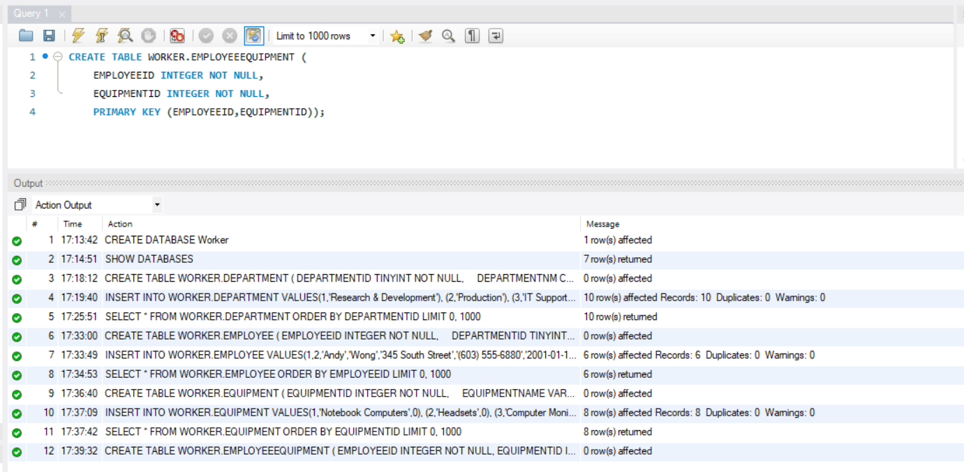

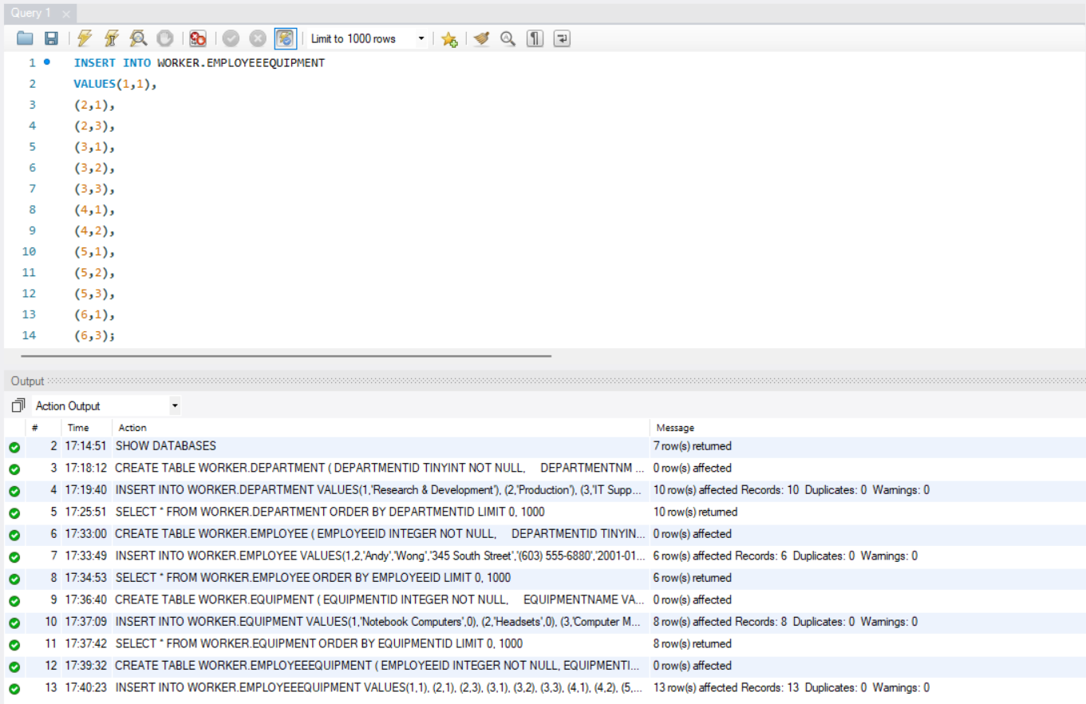

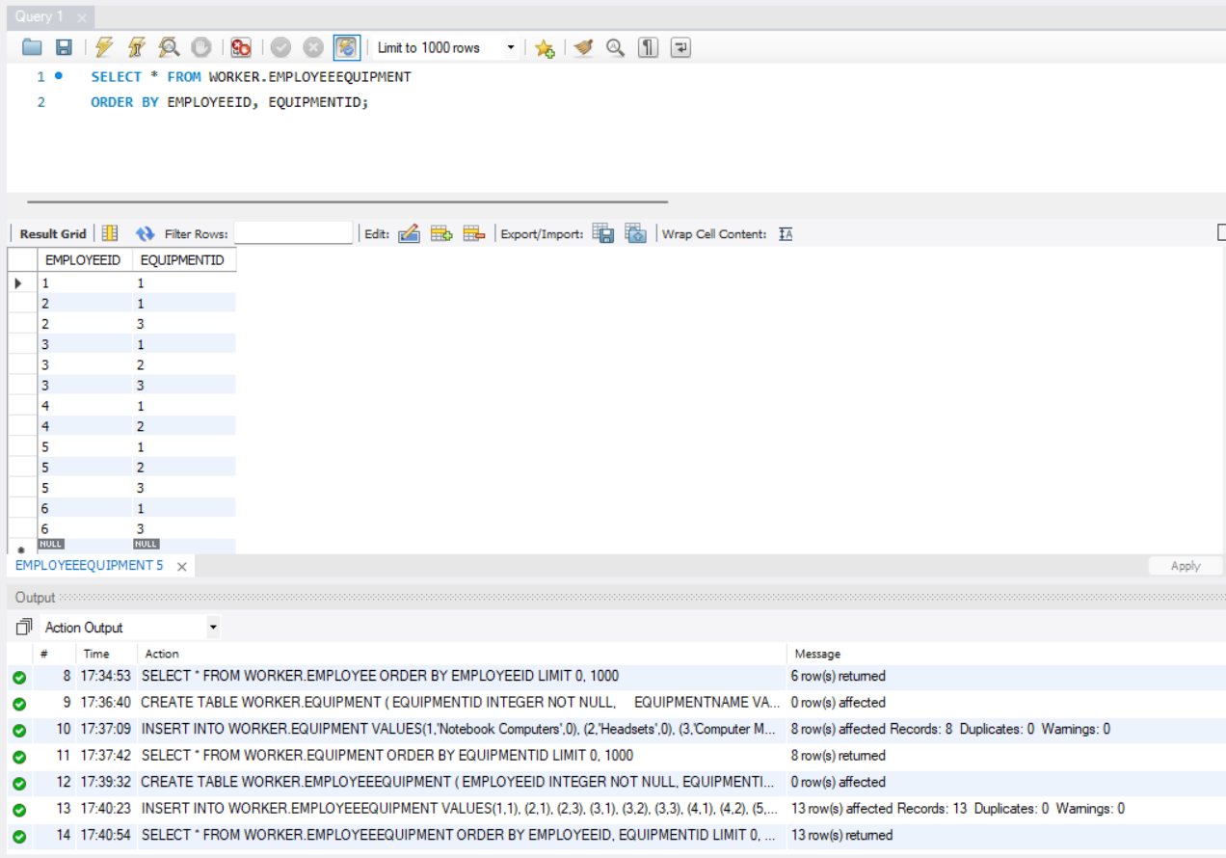

**Q6. Create the Training table in the Worker database (table must be based on Physical**

**Model Provided in the Assignment folder). (a) Columns, Primary Key (PK), Data Type &**

**length, and NULL/NOT NULL need to be implemented, as provided in the Physical Model.**

**(b) Show the table definition (DDL) that you implemented. (c) Insert the complete set of data**

**provided in the Excel file (uploaded in the Assignment folder) and show the insert**

**statements used. (d) Retrieve the data from the Training table by using the SELECT \***

**statement and order by PK column(s). Show the output. Make sure you show the print**

**screen of the complete set of the rows and columns. The rows must be ordered by PK**

**column(s).**

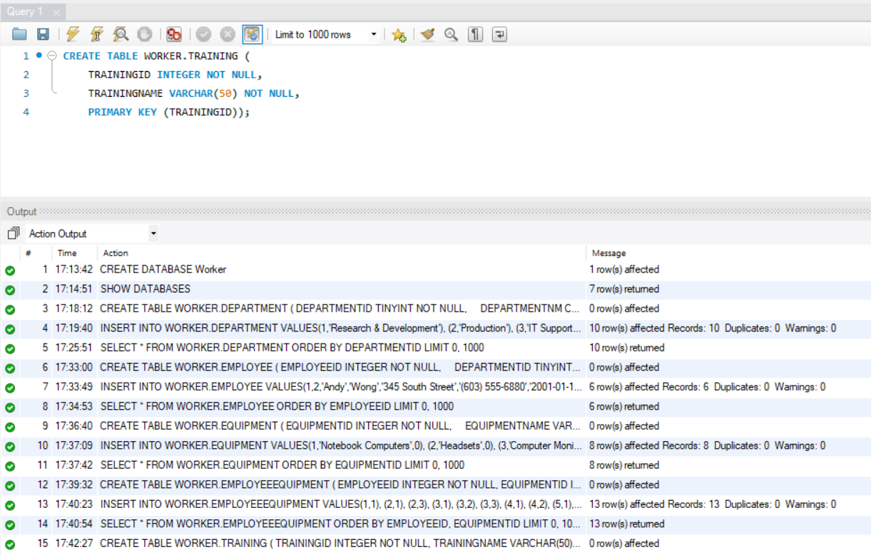

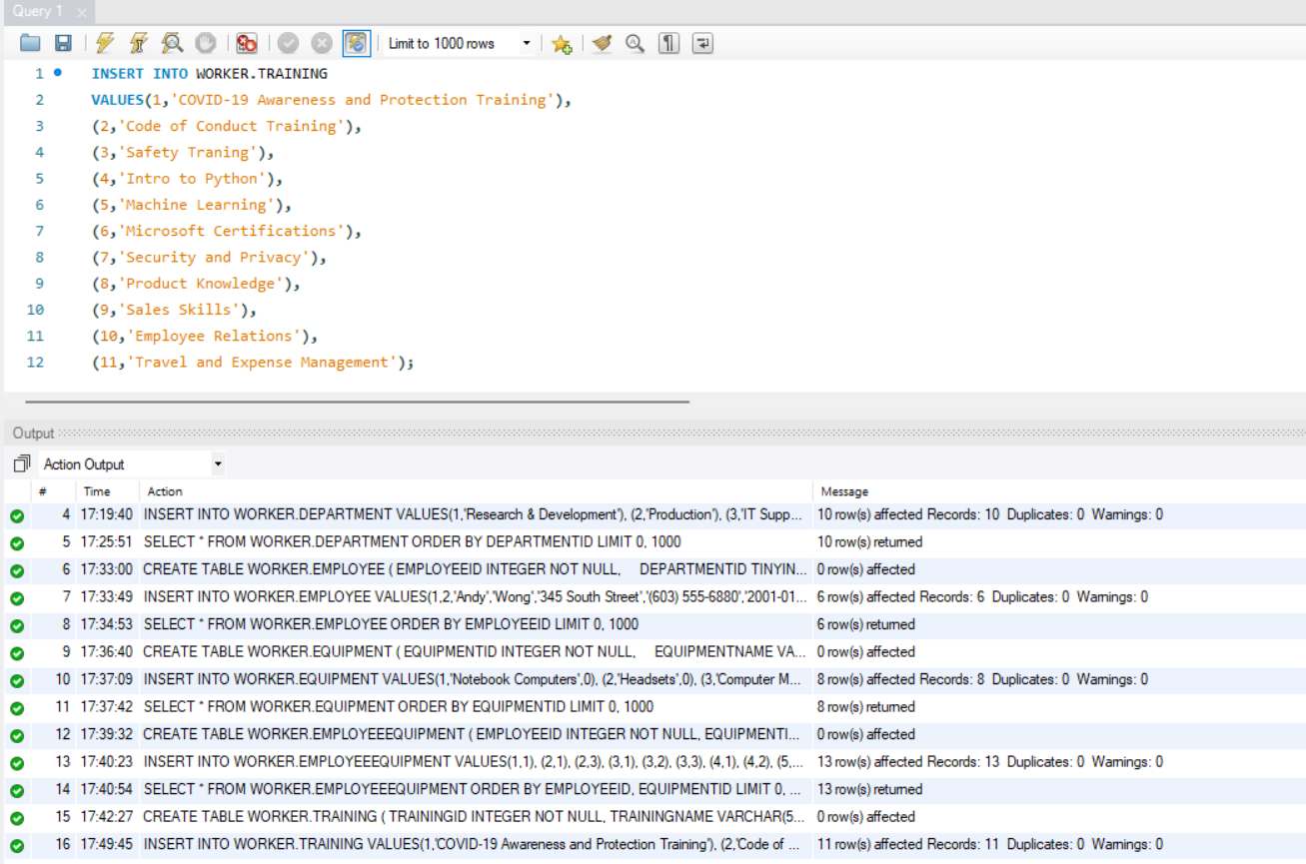

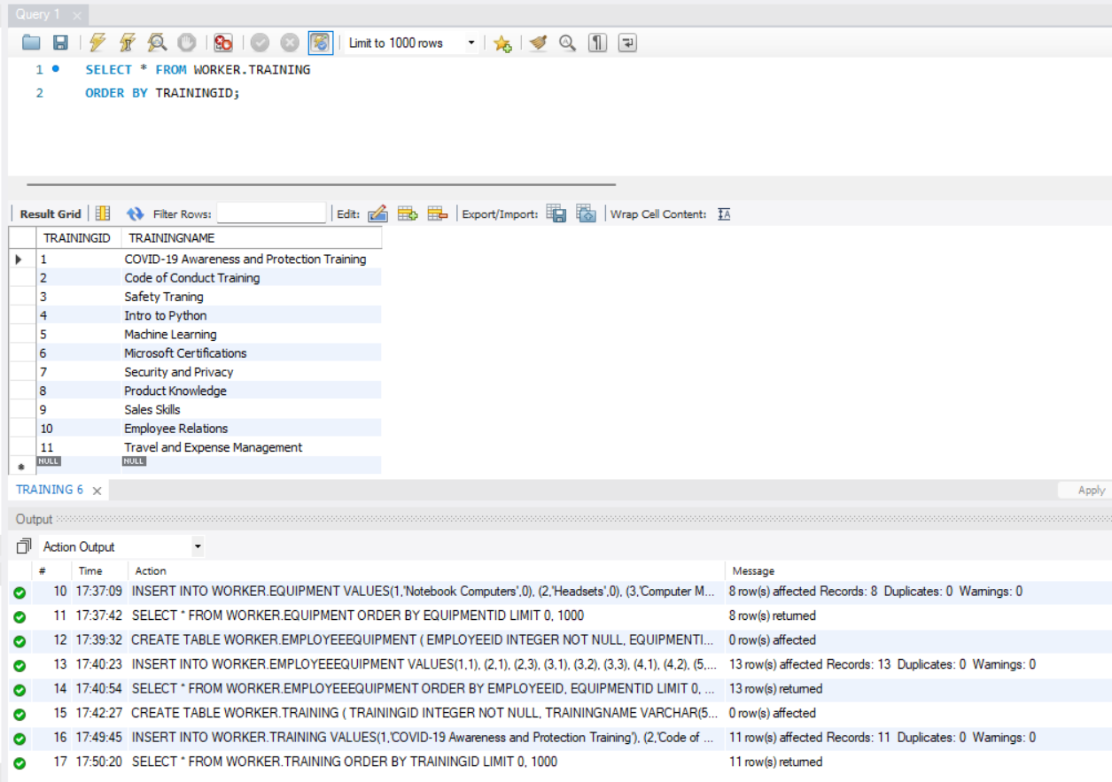

**Q7. Create the EmployeeTraining table in the Worker database (table must be based on**

**Physical Model Provided in the Assignment folder). (a) Columns, Primary Key (PK), Data Type**

**& length, and NULL/NOT NULL need to be implemented, as provided in the Physical Model.**

**(b) Show the table definition (DDL) that you implemented. (c) Insert the complete set of data**

**provided in the Excel file (uploaded in the Assignment folder) and show the insert**

**statements used. (d) Retrieve the data from the EmployeeTraining table by using the SELECT**

**\* statement and order by PK column(s). Show the output. Make sure you show the print**

**screen of the complete set of the rows and columns. The rows must be ordered by PK**

**column(s).**

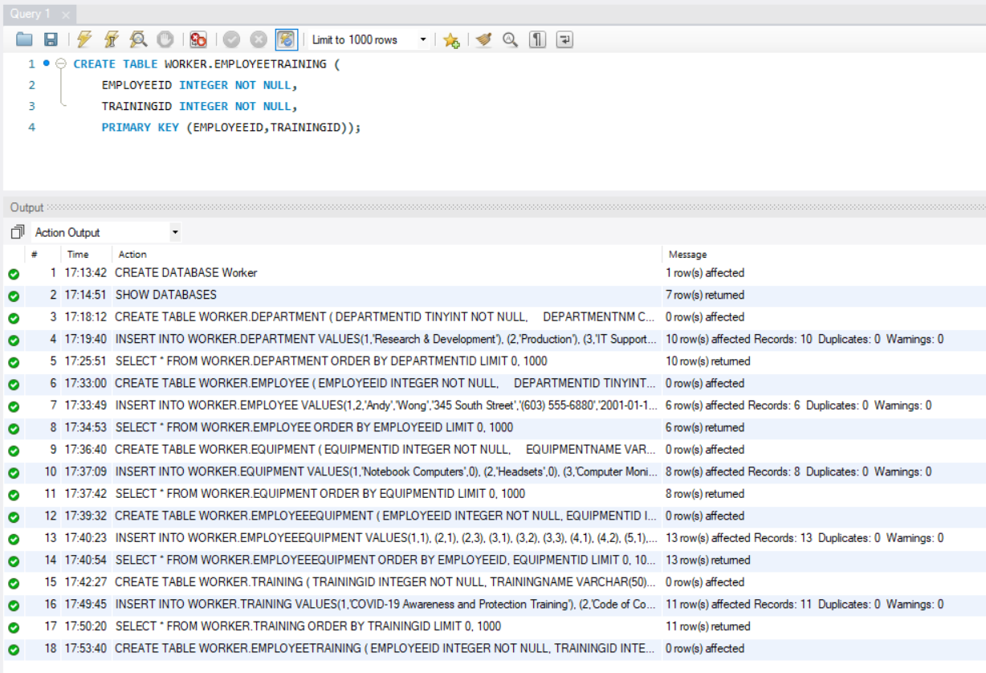

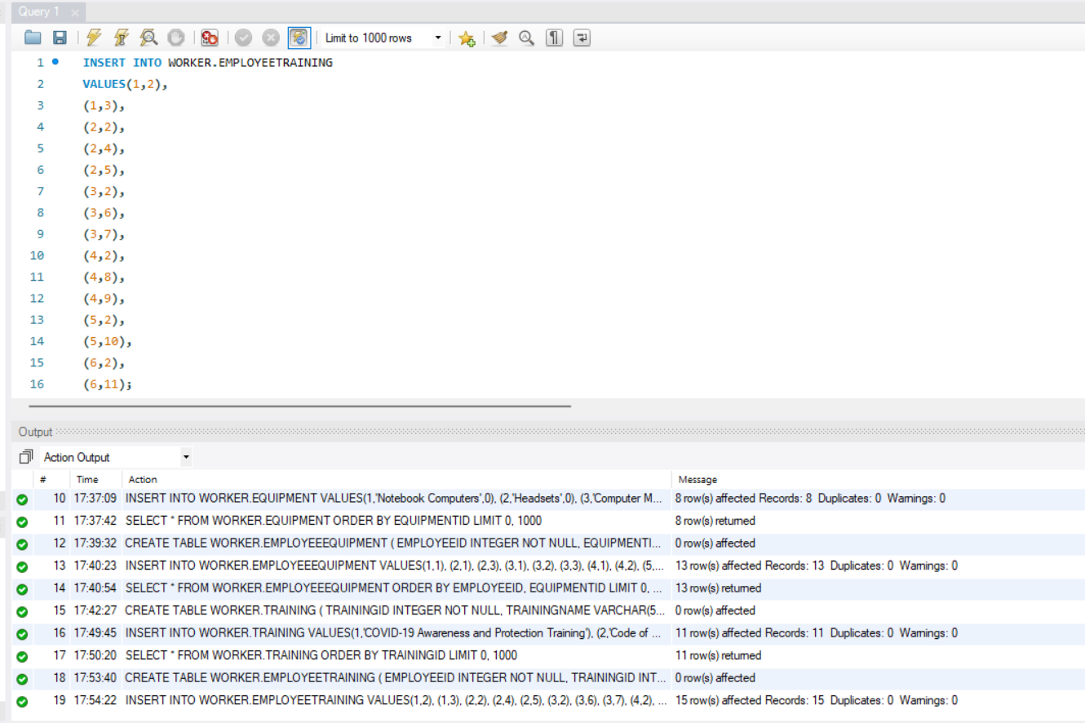

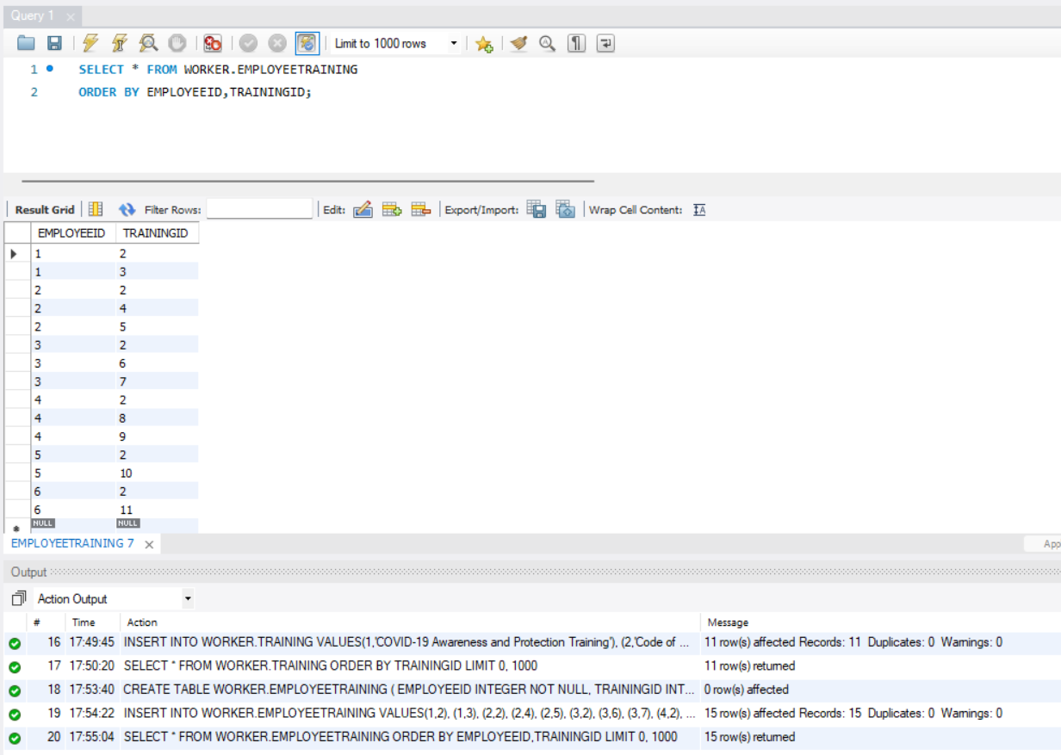

**Q8. Create the Trainer table in the Worker database (table must be based on Physical Model**

**Provided in the Assignment folder). (a) Columns, Primary Key (PK), Data Type & length, and**

**NULL/NOT NULL need to be implemented, as provided in the Physical Model. (b) Show the**

**table definition (DDL) that you implemented. (c) Insert the complete set of data provided in**

**the Excel file (uploaded in the Assignment folder) and show the insert statements used. (d)**

**Retrieve the data from the Trainer table by using the SELECT * statement and order by PK**

**column(s). Show the output. Make sure you show the print screen of the complete set of the**

**rows and columns. The rows must be ordered by PK column(s).**

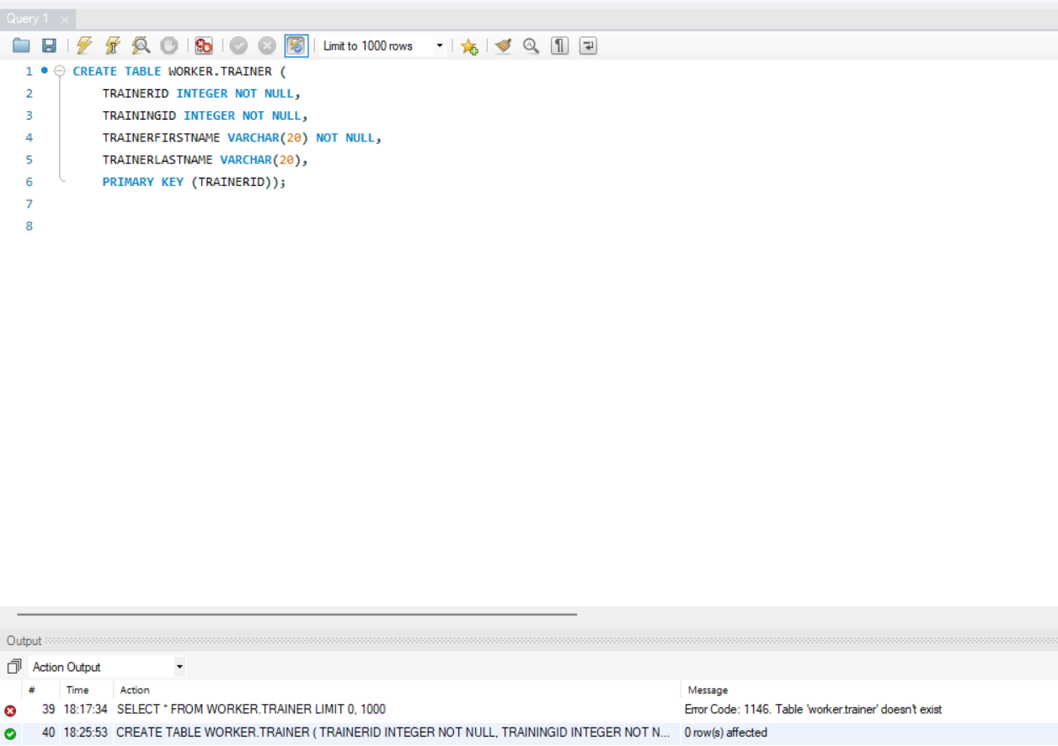

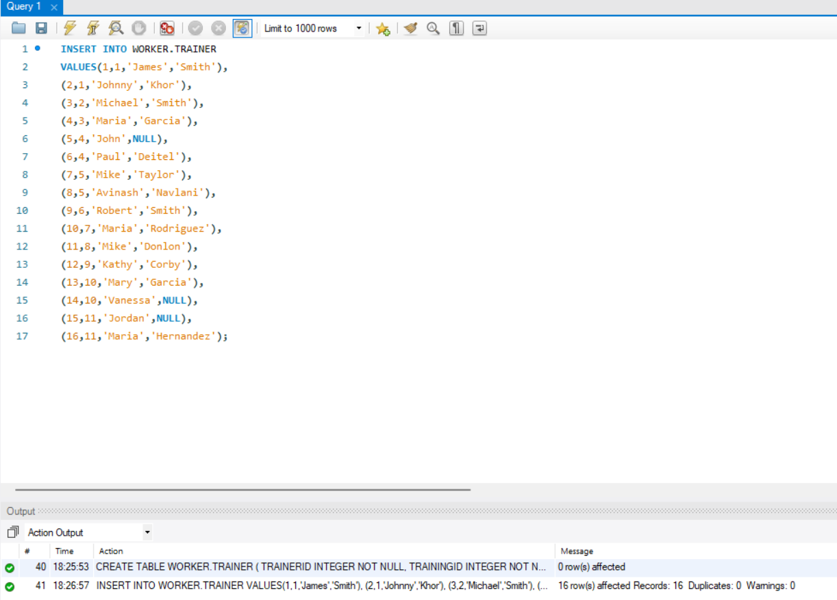

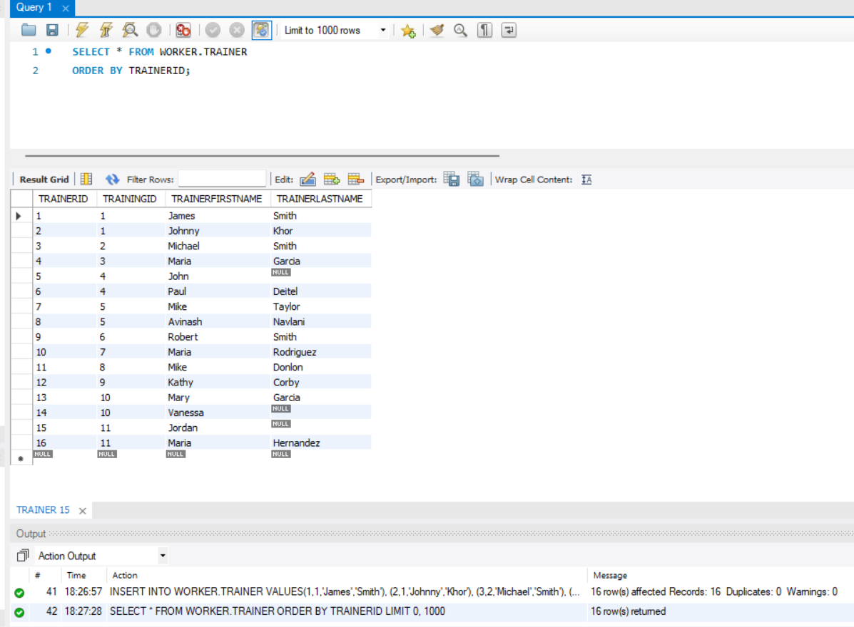

**Q9. Retrieve the data from the Trainer table by using the SELECT * statement with filter,**

**WHERE TrainerLastName IS NULL. Show the output. Make sure you show the print screen**

**of the complete set of the rows and columns. The rows must be ordered by PK column(s).**

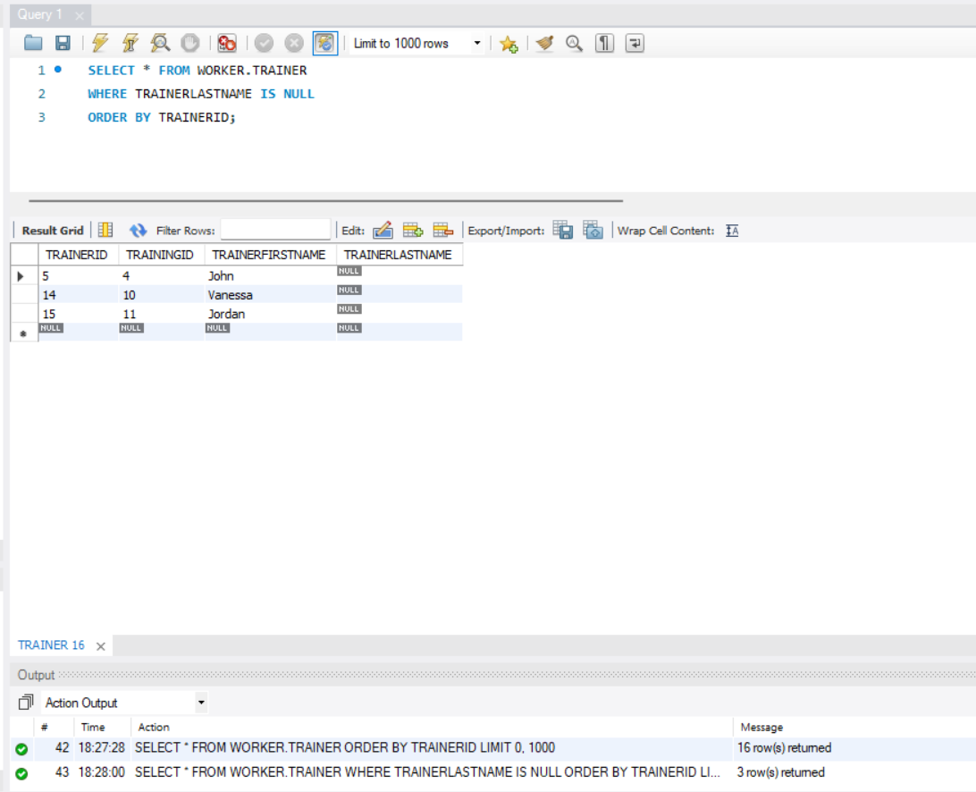

**Q10. By using the SHOW tables statements, show the list of tables you have created in the**

**Worker database. Show the screenshot of the execution of the above statements and**

**results. Make sure you show the print screen of the complete set of the rows and columns.**

**The rows must be ordered by PK column(s).**

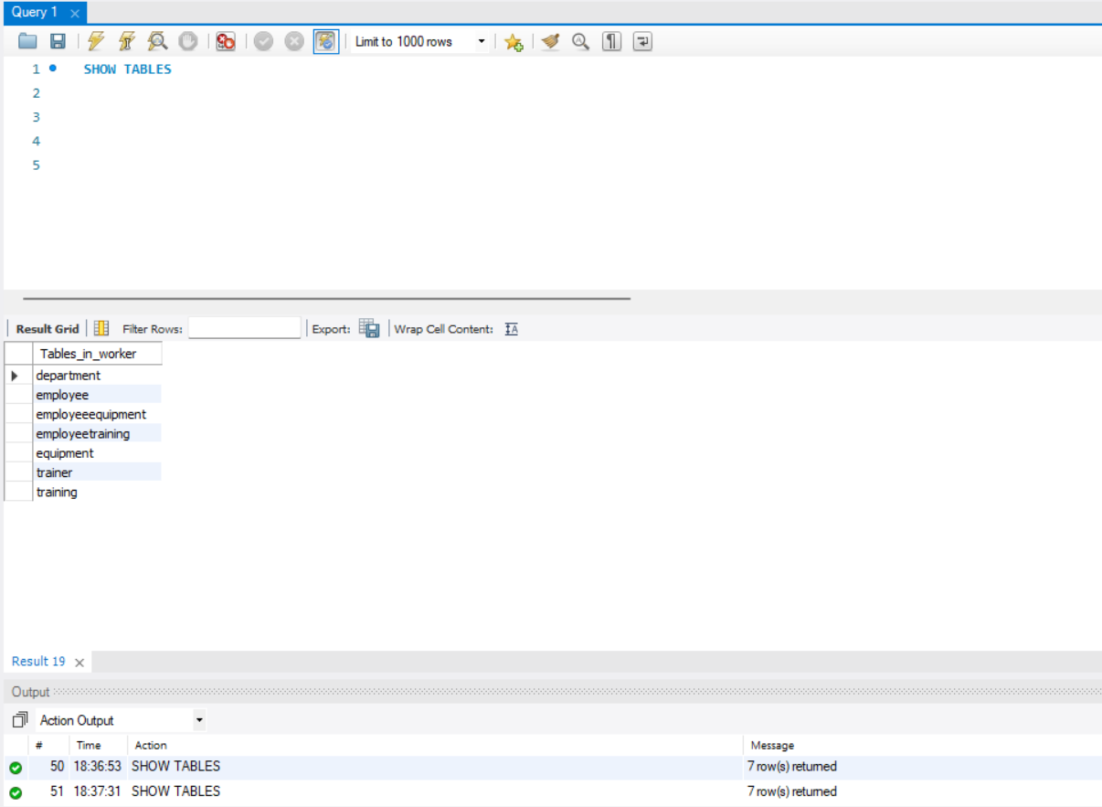

**Q11. Write a single-row subquery to display EmployeeID, FirstName, LastName, and**

**HireDate of employees hired after employee Vivek Pandey. Sort the results by EmployeeID.**

**Make sure you show the print screen of the complete set of the rows, and columns as**

**specified.**

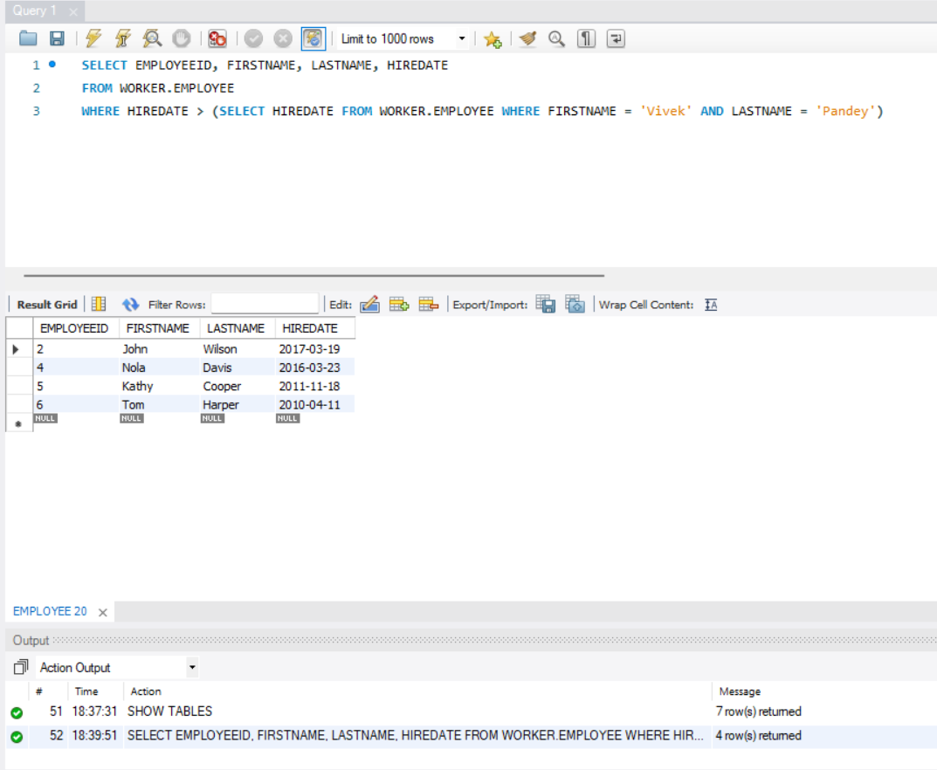

**Q12. Write a query to display FirstName, LastName, and TrainingName for employee Tom**

**Harper. Sort the results by TrainingName. Make sure you show the print screen of the**

**complete set of the rows, and columns as specified.**

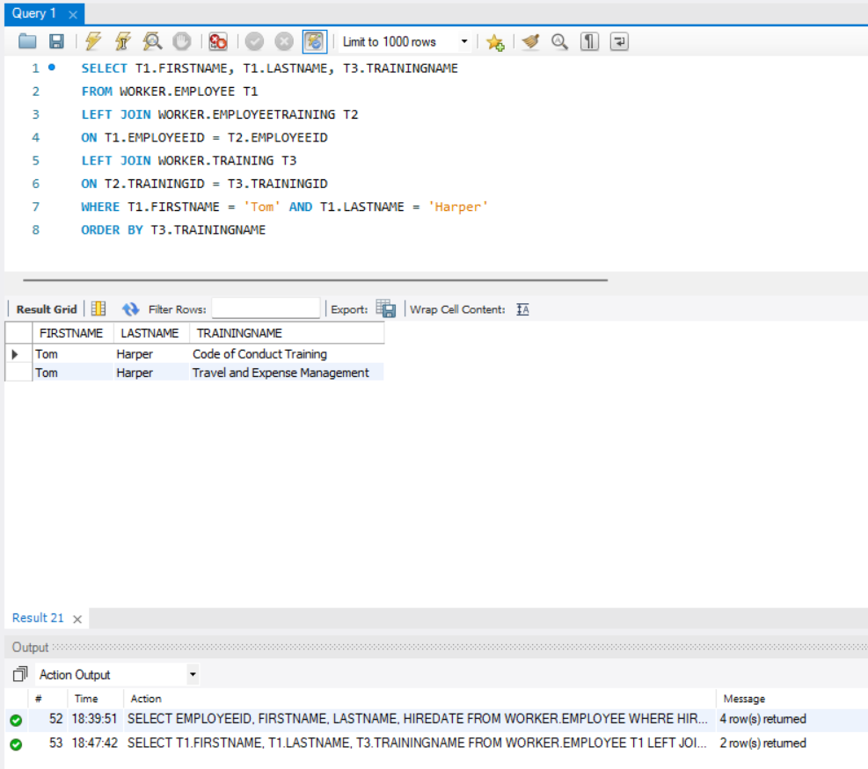

**Q13. Write a query to display the complete list of Trainings, and trainers (first and last name)**

**available for each training. Sort the output by TrainingName and Trainers' first and last name.**

**Make sure you show the print screen of the complete set of the rows, and columns as**

**specified.**

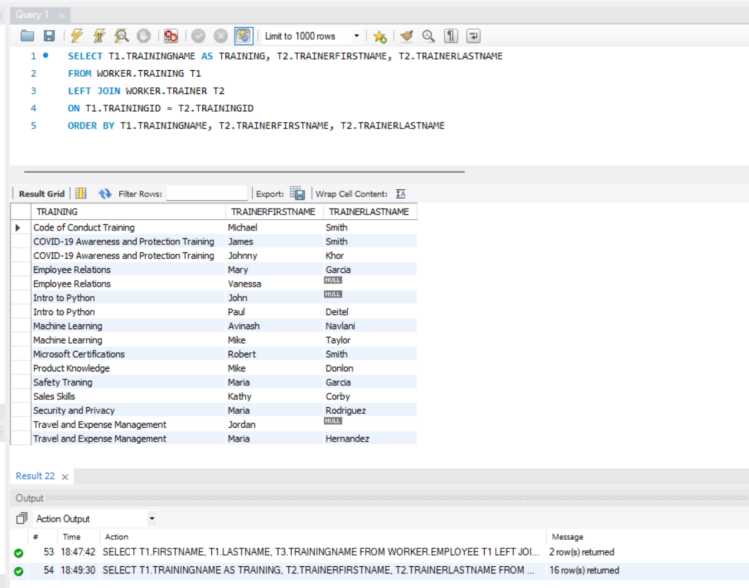

**Q14. Write a multiple-row subquery to display EmployeeID, FirstName, LastName, and**

**HireDate of employees who work for the following departments: Accounting and Finance, IT**

**Support, and Production. Sort the results by EmployeeID. Make sure you show the print**

**screen of the complete set of the rows, and columns as specified.**

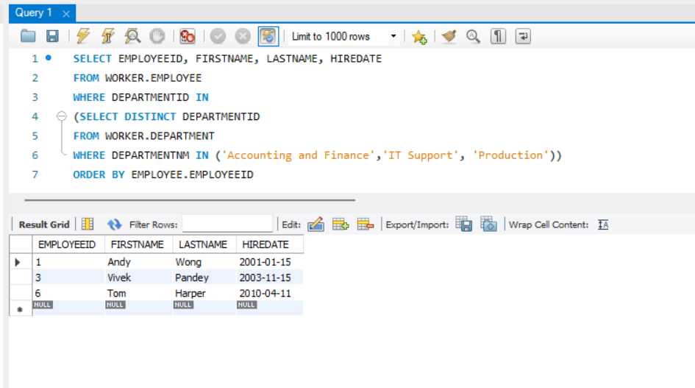

**Q15. Write a query to display the EmployeeID, FirstName, LastName, EquipmentName, and**

**EquipmentCostAmount for one of the employees. Sort the results by EmployeeID. Make sure**

**you show the print screen of the complete set of the rows, and columns as specified.**

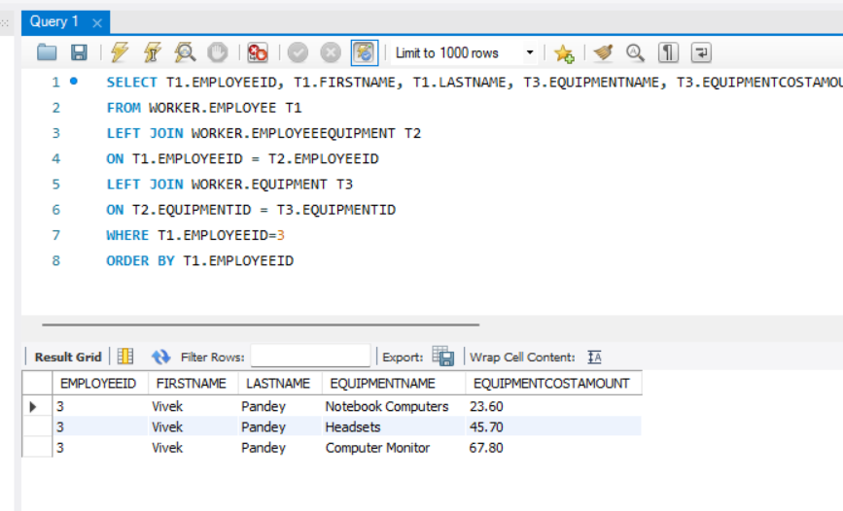

**Q16. Write a query to display the TrainingID, TrainingName, TrainerID, TrainerFirstName, and**

**TrainerLastName with the trainers who did not provide their last name. Sort the results by**

**TrainingID and TrainerID. Make sure you show the print screen of the complete set of the**

**rows, and columns as specified.**

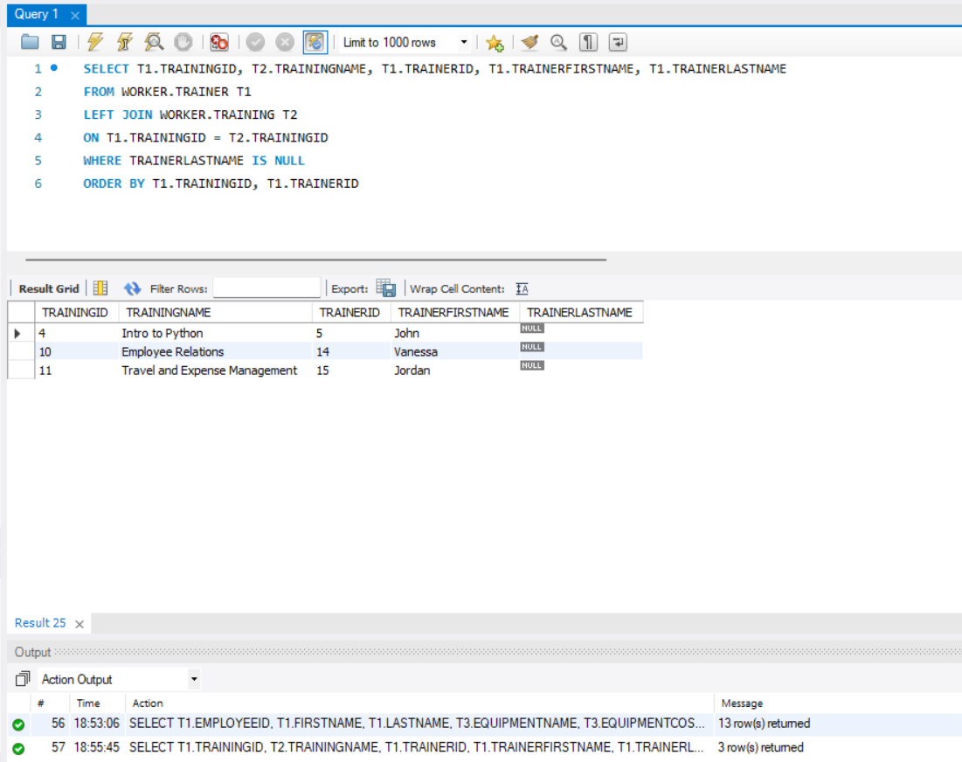

**Q17. Write a query to display the distinct list of equipments used by the current employees.**

**Sort the output by EquipmentName. Make sure you show the print screen of the complete**

**set of the rows, and columns as specified.**

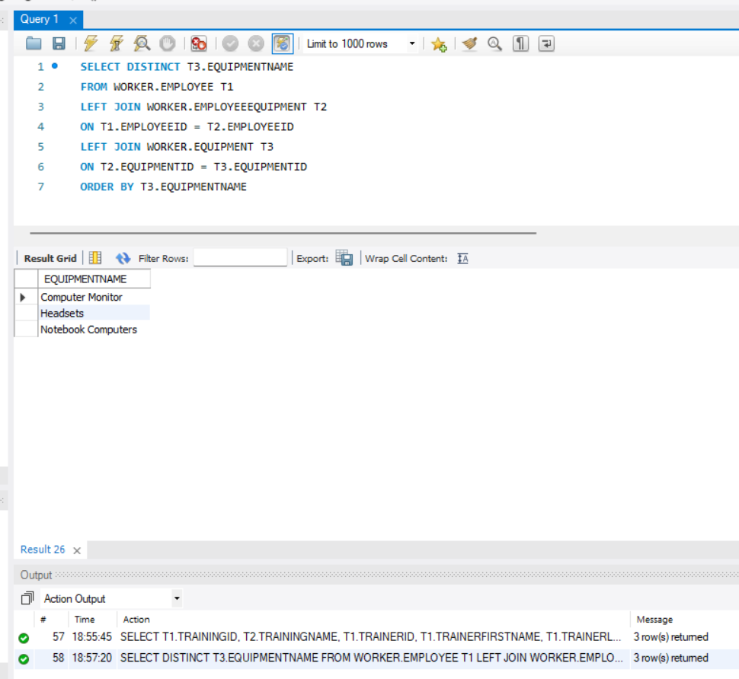

**Q18. Write a query to display the FirstName, LastName, TrainingName, and trainer(s) (with**

**first and last name in two separate columns) for one of the employees. Sort the results by**

**TrainingName and TrainerFirstName. Make sure you show the print screen of the complete**

**set of the rows, and columns as specified.**

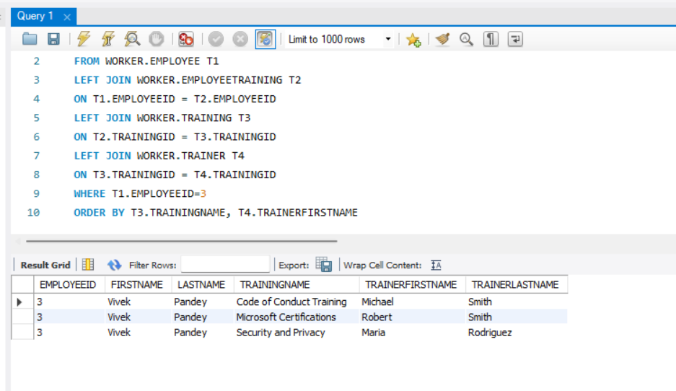

**Q19. Write a query to display the EmployeeID, FirstName, LastName, DepartmentID,**

**DepartmentName, EquipmentID, EquipmentName for all employees. Sort the results by**

**EmployeeID, DepartmentID, and EquipmentID. Make sure you show the print screen of the**

**complete set of the rows, and columns as specified.**

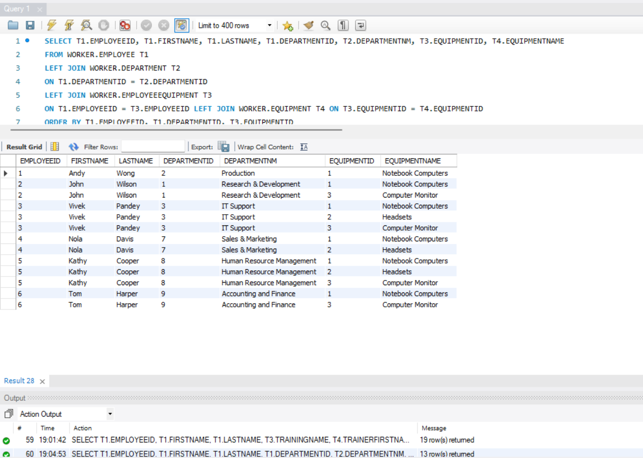

**Q20. Write a query to display the EmployeeID, FirstName, LastName, DepartmentID,**

**DepartmentName, TrainingID, TrainingName for all employees. Sort the results by**

**EmployeeID, DepartmentID, and TrainingID. Make sure you show the print screen of the**

**complete set of the rows, and columns as specified.**

